**Electronic Supplementary Material**

# Supplement to the article published in *Public Understanding of Science*:

# How the Public Evaluates Media Representations of Uncertain Science:

# An Integrated Explanatory Framework

**Chelsea L. Ratcliff**

**Rebekah Wicke**

Contents:

S1. Quality Checks and Participant Characteristics

S2. Experimental Stimuli

S3. EFA for the Preference for Information about Uncertain Science Scale

S4. Bivariate Correlations Between Study Variables

S5. Means and Standard Deviations for all Outcomes by Factor

S6. Serial Mediation Models for Source Attribution as Predictor

**S1. Quality Checks and Characteristics of the Final Sample**

**Quality Checks**

Based on *a priori* criteria, we removed cases ifa participant (a) did not give a meaningful answer to the attention check items, which were two open-ended questions about the article topic and research findings, or (b) completed the survey in under one-third median time. Out of 580 responses collected, this resulted in a final sample of 502 participants.

|  |  |  |
| --- | --- | --- |
| **Participant Characteristics** | **N** | **%** |
| **Sex** |  |  |
| Female | 263 | 52.4 |
| Male | 236 | 47.0 |
| Non-binary or prefer to self-describe | 3 | .6 |
| **Age Range** |  |  |
| 18-25 | 246 | 12.4 |
| 26-35 | 293 | 14.7 |
| 36-45 | 298 | 15.0 |
| 46-55 | 251 | 12.6 |
| 56-65 | 462 | 23.2 |
| 66 or older | 441 | 22.1 |
| **Race/Ethnicity\*** |  |  |
| Hispanic or Latino | 62 | 12.4 |
| White or Caucasian | 359 | 71.5 |
| Black or African American | 70 | 13.9 |
| American Indian or Alaska Native | 4 | .8 |
| Asian or Asian-American | 39 | 7.8 |
| Native Hawaiian or Other Pacific Islander | 2 | .4 |
| Different Race | 28 | 5.6 |
| **Race/Ethnicity Binary** |  |  |
| White non-Hispanic | 328 | 65.3 |
| Hispanic and/or non-White | 143 | 28.5 |
| **Income** |  |  |
| $0 to $25,000 | 115 | 22.9 |
| $25,001 to $50,000 | 144 | 28.7 |
| $50,001 to $75,000 | 102 | 20.3 |
| $75,001 to $100,000 | 63 | 12.5 |
| $100,001 to $125,000 | 27 | 5.4 |
| $125,001 to $150,000 | 19 | 3.8 |
| $150,001+ | 32 | 6.4 |
| **Highest education attained** |  |  |
| Less than high school | 8 | 1.6 |
| High school/GED | 102 | 20.3 |
| Some college | 108 | 21.5 |
| 2-year degree | 75 | 14.9 |
| 4-year degree | 138 | 27.5 |
| Advanced/professional degree | 71 | 14.1 |
| *Notes.* *N* = 502. *Participants could identify as more than one race and/or ethnicity, but many used the ‘Different Race’ category to report mixed race. | | |

# S2. Experimental Stimuli

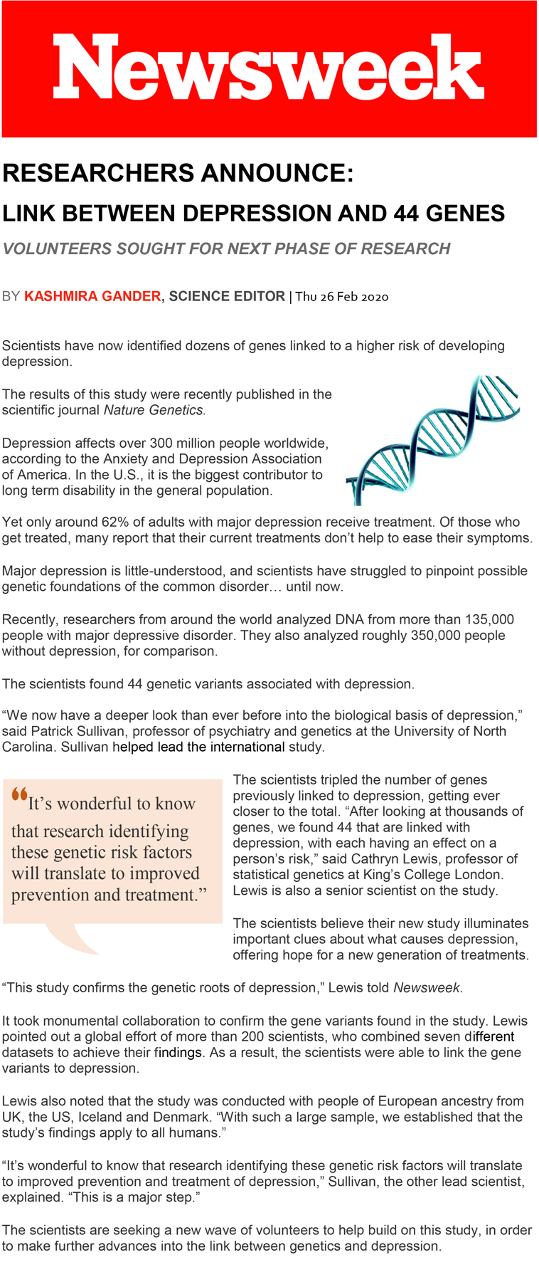Condition 1: Certainty (Affiliated Scientist)

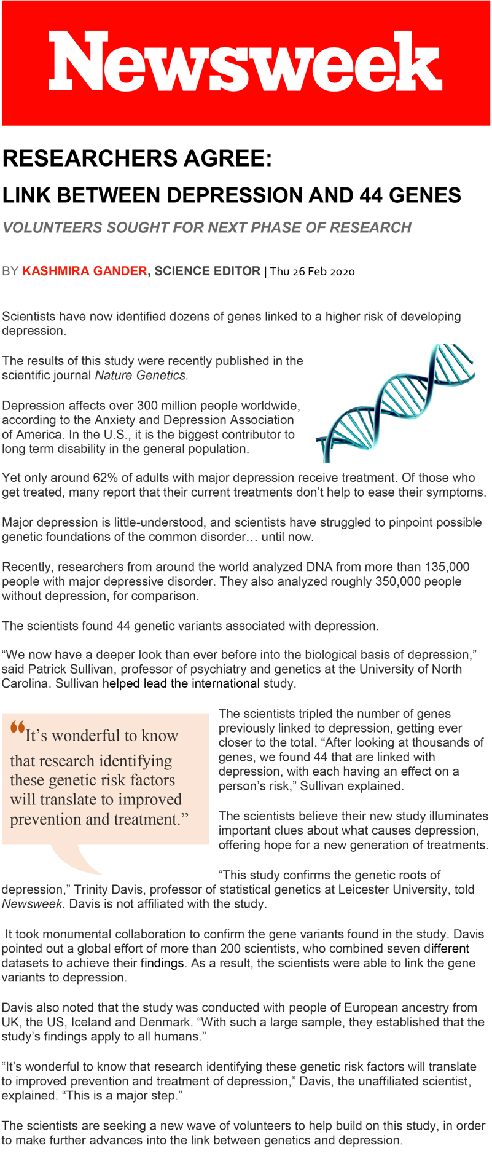Condition 2: Certainty (Unaffiliated Scientist)

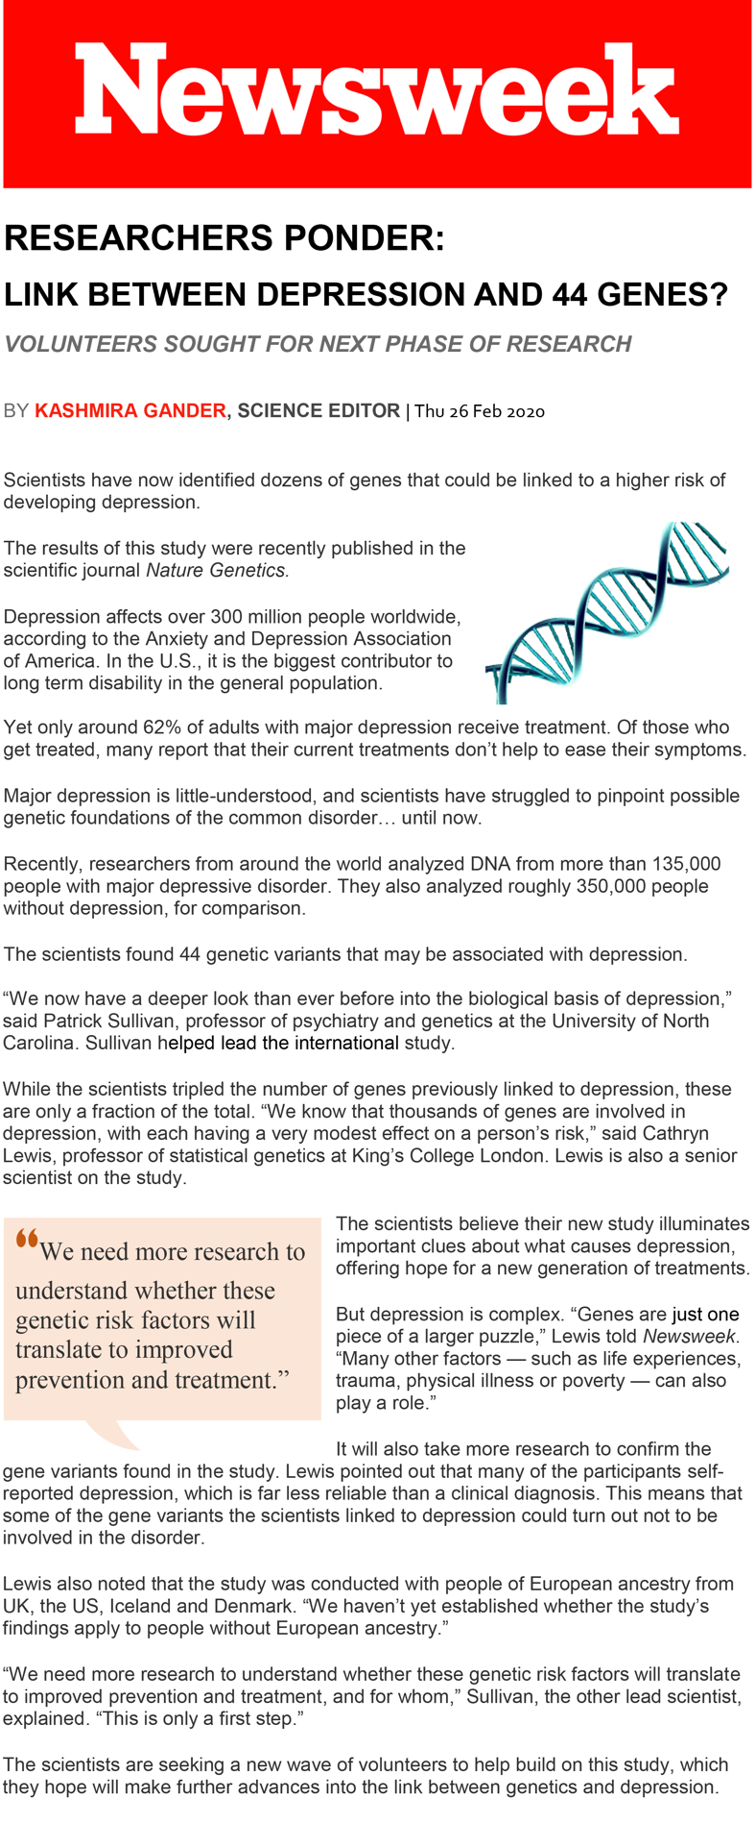Condition 3: Uncertainty (Affiliated Scientist)

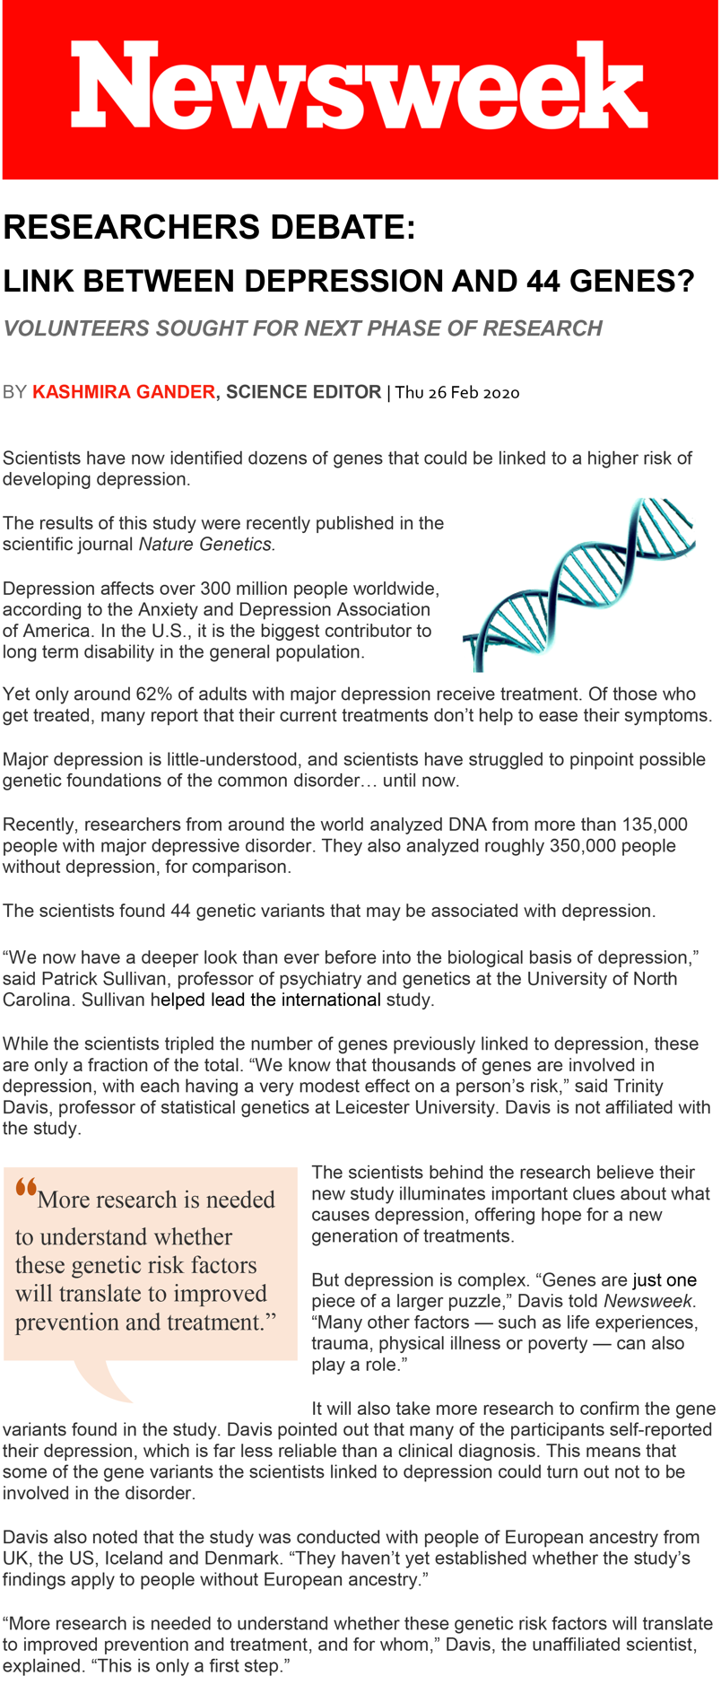Condition 4: Uncertainty (Unaffiliated Scientist)

# S3. Development of the Preference for Information about Uncertain Science Scale

We created a set of items (presented in main manuscript) by consulting health science journalists and the extant literature on scientists’ and journalists’ beliefs about how nonexpert audiences manage information about uncertain science (Friedman et al., 1999; Maier et al., 2016). To examine the structure and suitability of the initial measure, we performed exploratory factor analysis (EFA) using the full final sample (*N* = 502). We used the principal axis factoring (PAF) factor analytic method and direct oblimin rotation to allow factors to correlate. This method provides adequate results in most situations compared to other factor analytic methods and is robust to data non-normality (Howard, 2016).

Factor retention decisions were guided by both the Kaiser criterion (eigenvalues greater than 1) and visual scree plot analysis. Prior to interpretation, the Bartlett’s test of sphericity and Kaiser-Meyer-Olkin (KMO) measure of sampling adequacy were used to inspect the data for violations of statistical assumptions. Data is considered to have acceptable properties if Bartlett’s test is statistically significant and KMO value is above .80 (Howard, 2016). Assessment of items was guided by the “40-30-20” rule (Howard, 2016); that is, a cutoff factor loading of .40 should be used, and an item should not load onto multiple factors greater than .30 unless loading onto the primary factor is at least .20 higher.

The data did not violate statistical assumptions: Bartlett’s test was significant, *X2* = 1745.29, *p* < .001 and KMO was .84. Results were similar for the 7-item scale with positively-worded items only: Bartlett’s test *X2* = 1527.64, *p* < .001, KMO = .87. However, while all seven positively-worded items loaded onto a single factor, the three reverse-worded items loaded onto second and third factors, which did not correlate with the first factor (*r* = –.14 and .05, respectively). Because a factor should optimally have at least three items (Fabrigar et al., 1999), and these three reverse-worded items did not together form a factor, these were not retained as additional factors.

The seven positively-worded items exhibited a single-factor structure with acceptable loadings onto the factor (between .674 and .818). The 7-item scale explained 56.34% of the total amount of variance, which is considered typical for social science research (UCLA Statistical Consulting Group, n.d.). It also demonstrated superior reliability (*α* = .87 for the 7-item scale, versus .62 for the 10-item scale). Taking these results into account, we used the 7-item scale for analyses.

References not included in main manuscript:

Fabrigar, L. R., Wegener, D. T., MacCallum, R. C., & Strahan, E. J. (1999). Evaluating the use of exploratory factor analysis in psychological research. *Psychological Methods*, *4*(3), 272–299. <https://doi.org/10.1037/1082-989X.4.3.272>

Howard, M. C. (2016). A review of exploratory factor analysis decisions and overview of current practices: What we are doing and how can we improve? *International Journal of Human-Computer Interaction*, *32*(1), 51–62. <https://doi.org/10.1080/10447318.2015.1087664>

UCLA Statistical Consulting Group. (n.d.). A practical introduction to factor analysis: Exploratory factor analysis. Retrieved from <https://stats.idre.ucla.edu/spss/seminars/introduction-to-factor-analysis/a-practical-introduction-to-factor-analysis/>.

# S4. Bivariate Correlations Between Study Variables

|  |  |  |  |  |  |  |  |  |  |  |  |  |
| --- | --- | --- | --- | --- | --- | --- | --- | --- | --- | --- | --- | --- |
|  | 1 | 2 | 3 | 4 | 5 | 6 | 7 | 8 | 9 | 10 | 11 | 12 |
| 1. Factor: Uncertain | ---- |  |  |  |  |  |  |  |  |  |  |  |
| 2. Factor: Source | -.01 | ---- |  |  |  |  |  |  |  |  |  |  |
| 3. Age | .00 | -.01 | ---- |  |  |  |  |  |  |  |  |  |
| 4. Race | .02 | -.05 | -.16*** | ---- |  |  |  |  |  |  |  |  |
| 5. Ethnicity | -.03 | -.02 | .18*** | -.18*** | ---- |  |  |  |  |  |  |  |
| 6. Education | -.07 | .05 | .01 | .03 | -.04 | ~~----~~ |  |  |  |  |  |  |
| 7. Income | -.12* | .02 | -.01 | -.07 | .02 | .46*** | ---- |  |  |  |  |  |
| 8. Perceived Uncertainty | .33*** | .01 | .15** | .01 | .08 | .01 | -.03 | ---- |  |  |  |  |
| 9. Pref Uncertain Info | -.04 | -.06 | .00 | .01 | -.04 | .11* | .10* | -.03 | ---- |  |  |  |
| 10. Scientist Trust | .01 | -.07 | -.01 | -.14** | -.01 | .00 | .00 | -.36*** | .42*** | ---- |  |  |
| 11. News Credibility | -.02 | -.06 | -.04 | -.13** | -.03 | -.04 | -.06 | -.39*** | .37*** | .88*** | ---- |  |
| 12. Perceived Objectivity | -.07 | -.10* | .03 | -.13** | .00 | -.06 | -.02 | -.40*** | .35*** | .77*** | .77*** | ---- |
| 13. Willing to Participate | -.04 | -.07 | -.06 | -.08 | -.04 | .12** | .10* | -.20*** | .39*** | .37*** | .29*** | .25*** |

*Notes*: *N* = 502. Uncertainty factor is coded as 0 = Certain, 1 = Uncertain. Source factor is coded as 0 = Affiliated scientist, 1 = Unaffiliated scientist. Race is coded as 1 = white, 2 = nonwhite/mixed race; Ethnicity is coded 1 = Hispanic, 2 = non-Hispanic. Age, education, and income are multilevel variables (see Table S1). Pref Uncertain Info = preference for information about uncertain science.

\**p* < .05, \*\**p* < .01, \*\*\**p* < .001

S5.

Means and Standard Deviations for Uncertainty Factor

|  |  |  |
| --- | --- | --- |
| *Grouped by factor:* | *Scientific Certainty*  *(N = 245)* | *Scientific Uncertainty*  *(N = 257)* |
| Scientist Trustworthiness | 3.82 (.76) | 3.84 (.78) |
| News Credibility | 3.68 (.75) | 3.65 (.79) |
| Scientist Objectivity | 5.41 (1.31) | 5.22 (1.41) |
| Willingness to Participate | 4.55 (1.24) | 4.45 (1.32) |
| *Notes*: Means (*SD*s in parentheses). As reported in the main manuscript, no means were significantly different. | | |

Means and Standard Deviations for Source Factor

|  |  |  |
| --- | --- | --- |
| *Grouped by factor:* | *Affiliated Scientists*  *(N = 248)* | *Unaffiliated Scientists*  *(N = 254)* |
| Scientist Trustworthiness | 3.89 (.79) | 3.78 (.74) |
| News Credibility | 3.71 (.79) | 3.62 (.74) |
| Scientist Objectivity | **5.45 (1.31)** | **5.18 (1.40)** |
| Willingness to Participate | 4.58 (1.27) | 4.42 (1.29) |
| *Notes*: Means (*SD*s in parentheses). As reported in the main manuscript, only the means for perceived objectivity were significantly different. | | |

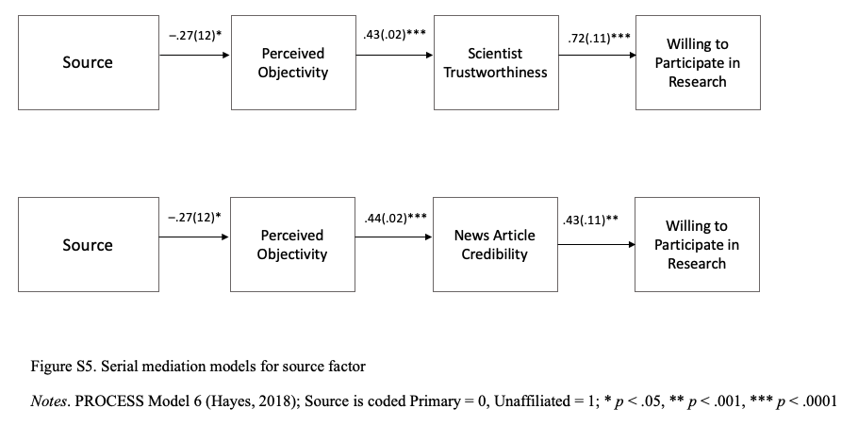

Figure S6. Serial mediation models for source attribution as predictor

*Notes*. PROCESS Model 6 (Hayes, 2018); Source factor is coded 0 = Affiliated scientist, 1 = Unaffiliated scientist.

* *p* < .05, ** *p* < .001, *** *p* < .0001